Chinese Immigration
The Chinese experience in America began with dreams of gold, as legends of instant wealth in California lured hopeful adventurers across the Pacific Ocean. Those dreams soon lost their luster, though; these sojourners found mostly hard times and persecution, and scrambled to survive in a strange country.
Only through decades of struggle, isolation, and slow progress were Chinese Americans able to find a secure place in the life of the nation. Today, though, a new surge of growth and cultural vitality promises to transform the Chinese American community, and to reshape American life for future generations.
Searching for the Gold Mountain
In the 1840s, the news circled the globe: There was gold in California, and fortunes could be made by anyone who seized the opportunity. Within weeks, dreamers from all over the globe came streaming into America's port cities, hoping to stake a claim and strike it rich. China was not immune to this new gold fever. Word of a mountain of gold across the ocean arrived in Hong Kong in 1849, and quickly spread throughout the Chinese provinces. By 1851, 25,000 Chinese immigrants had left their homes and moved to California, a land some came to call gam saan, or "gold mountain".
Historically, the Chinese had never been strangers to emigration. For long centuries, Chinese travelers had crisscrossed the world and made new homes for themselves in faraway lands. Colonies of Chinese merchants, bankers, miners, and artists established themselves in countries from Polynesia to Peru, bringing their families with them and building thriving communities. In America, though, things would turn out differently.
Once the Chinese immigrants arrived in California, they found that the gold mountain was an illusion. Mining was uncertain work, and the gold fields were littered with disappointed prospectors and hostile locals. Work could be scarce, and new arrivals sometimes found it difficult to earn enough to eat, let alone to strike it rich. Even worse, they soon discovered that they were cut off from their families: With no source of money, the immigrants could not pay for their wives and children to make the long voyage from China, and could not go back home themselves. As the dream of gold faded, these men found themselves stranded in a strange new land far from home. It was a land that did not welcome them, a land that afforded them few means of survival, and a land in which they were very much alone.
What affect do you think this isolation had on the Chinese immigrants? What kind of community could they make for themselves?
Struggling for Work
Once they realized how difficult their situation was, the first generation of Chinese immigrants scrambled to find some way to earn a living wage. The vast majority of this first group, in the 1840s and 1850s, was young and male, and many of them had little formal education and work experience. Once in California, they had to find work that required little facility in English, and that required skills that could be learned quickly.
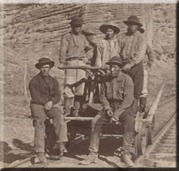
Construction of the Union Pacific Railroad
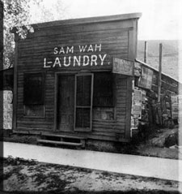
The railroads were tailor-made for this new pool of Chinese labor. In the middle of the nineteenth century, the U.S. railroad companies were expanding at a breakneck pace, straining to span the continents as quickly--and cheaply--as they could. The work was brutally difficult, the pay was low, and workers were injured and killed at a very high rate. For Chinese laborers, though, it represented a chance to enter the workforce, and they accepted lower wages than many native-born U.S. workers would have. On the Central Pacific Railroad alone, more than ten thousand Chinese workers blasted tunnels, built roadbeds, and laid hundreds of miles of track, often in freezing cold or searing heat. When, in 1869, the final spike was driven into the rails of the Transcontinental Railroad, after a record-breaking five years of construction, few Chinese faces appeared in photographs of the event. But the railroad could never have been completed as quickly as it was without the toil of Chinese railway men--unknown hundreds of whom lost their lives along its route.
Once the rail construction was completed, Chinese immigrants found work in a variety of industries, from making shoes and sewing clothes to rolling cigars. Since language barriers and racial discrimination barred them from many established trades, however, they often created opportunities for themselves and launched new businesses. Many of the shops, restaurants, and laundries in the growing mining towns of California were operated by Chinese immigrants. Chinese immigrants also played an important role in developing much of the farm land of the western U.S., including the plantations of Hawaii and the vineyards of California.
Intolerance
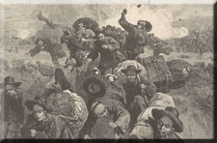
Massacre of the Chinese
at Rock Springs, Wyoming
Even as they struggled to find work, Chinese immigrants were also fighting for their lives. During their first few decades in the United States, they endured an epidemic of violent racist attacks, a campaign of persecution and murder that today seems shocking. From Seattle to Los Angeles, from Wyoming to the small towns of California, immigrants from China were forced out of business, run out of town, beaten, tortured, lynched, and massacred, usually with little hope of help from the law. Racial hatred, an uncertain economy, and weak government in the new territories all contributed to this climate of terror and bloodshed. The perpetrators of these crimes, which included Americans from many segments of society, largely went unpunished. Exact statistics for this period are difficult to come by, but a case can be made that Chinese immigrants suffered worse treatment than any other group that came voluntarily to the U.S.
One traveler from the east coast, in his account of life in California, observed that "To abuse a Chinaman; to rob him; to kick and cuff him; even to kill him, have been things not only done with impunity by mean and wicked men, but even with vain glory.
"Had 'John'--here and in China alike the English and Americans nickname every Chinaman 'John'--a good claim, original or improved, he was ordered to 'move on'--it belonged to someone else. Had he hoarded a pile, he was ordered to disgorge; and, if he resisted, he was killed. Worse crimes even are known against them; they have been wantonly assaulted and shot down or stabbed by bad men, as sportsmen would surprise and shoot their game in the woods. No one was so low, so miserable, that he did not despise the Chinaman, and could not outrage him."

Legislative Harassment
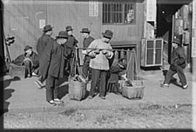
Vegetable peddler, Chinatown, San Francisco
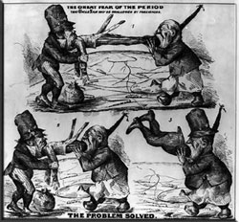
While Chinese immigrants in the U.S. had to deal with the threat of armed attackers, they also were harassed by punitive laws and regulations, many targeted solely at them. The Foreign Miners License tax law required all non-native born workers to pay the exorbitant rate of twenty dollars per month for the right to mine. The Sidewalk Ordinance of 1870 banned the Chinese method of carrying vegetables and carrying laundry on a pole, while in San Francisco, the Queue Ordinance of 1873 outlawed the wearing of long braids by men, a Chinese custom. Chinese immigrants were prohibited from working for federal, state, and local governments, and from educating their children in public schools. For several decades, a law was in place that prevented Chinese immigrants from testifying in court against Americans of European descent--effectively placing thousands of immigrants outside the protection of the law.
In the economic depression of the 1870s, hostile attitudes toward Chinese immigrants only became worse. Although most immigrants to the U.S. during this period were not Chinese, Chinese immigrants were often singled out as the cause of the nation's high employment rate and low wages. In one 1878 pamphlet, a labor organization warned against the damaging effects of Chinese businesses.
"MEN FROM CHINA come here to do LAUNDRY WORK. The China Empire contains 600,00,000 (six hundred millions) inhabitants.
The supply of these men is inexhaustible.
Every one doing this work takes BREAD from the mouths of OUR WOMEN.
So many have come of late, that to keep at work, they are obliged to cut prices."
Exclusion
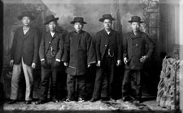
Chinese American men
The door to the Chinese American dream was finally slammed shut in 1882, when Congress passed the Chinese Exclusion Act. This act was the first significant restriction on free immigration in U.S. history, and it excluded Chinese laborers from the country under penalty of imprisonment and deportation. It also made Chinese immigrants permanent aliens by excluding them from U.S. citizenship. Chinese men in the U.S. now had little chance of ever reuniting with their wives, or of starting families in their new home.
For all practical purposes, the Exclusion Act, along with the restrictions that followed it, froze the Chinese community in place in 1882, and prevented it from growing and assimilating into U.S. society as European immigrant groups did. Later, the 1924 Immigration Act would tighten the noose even further, excluding all classes of Chinese immigrants and extending restrictions to other Asian immigrant groups. Until these restrictions were relaxed in the middle of the twentieth century, Chinese immigrants were forced to live a life apart, and to build a society in which they could survive on their own.
Building Communities
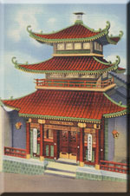
Chinese Telephone Exchange,
Chinatown, San Francisco
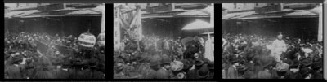
In the face of a hostile public, and in response to hard times and legal exclusion, Chinese immigrants began to build communities unlike any others in North America: Chinatowns. With the completion of the railroads and the end of the gold rush, Chinese immigrants moved in increasing numbers to urban areas. There, they began to congregate in Chinese-only neighborhoods that soon became known, to Chinese and non-Chinese residents alike, as separate, nearly independent, cities within the city.
A Chinatown served as a safe haven and second home for Chinese immigrants, a place to shop for familiar food, to worship in a traditional temple, or to catch up on the news from the old country. It also was a good place to do business: The shops and factories in a Chinatown were almost exclusively Chinese-owned, and would hire Chinese workers when many non-Chinese businesses would not. By the turn of the century, Chinatowns had sprung up in cities, from San Diego to El Paso to Connecticut, and formed a network that crossed the continent.
Taking Care of Our Own
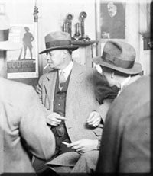
Frank Moy, King of Chicago's Chinatown
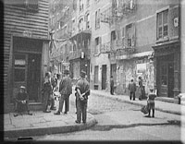
Chinatowns also provided Chinese immigrants with the social support networks that were not available to them anywhere else. District associations, made of up immigrants who came from the same part of China, performed many of the roles that government agencies or charities would otherwise have fulfilled: They found jobs for new arrivals, cared for the sick and poor, and arranged for the bones of the dead to be sent back to their homeland. These associations soon became like a secondary system of government, and their leaders served as representatives to the non-Chinese population, sometimes becoming well-known public figures. Organized crime also arrived in Chinatowns, sometimes associated with organizations called tongs, but the district associations fought, usually successfully, to keep the neighborhoods free of serious gang activity.
Other civic organizations also formed to provide needed services in America's Chinatowns. In 1925, for example, fifteen service groups in San Francisco's Chinatown combined their efforts to raise funds to build the city's Chinese hospital. District associations, social service organizations, cultural groups, churches, and temples all played an important role in the social life of Chinatowns. Though most Chinese Americans now live outside of Chinatowns, many still participate in these organizations as a means of strengthening the fabric of community life.
Chinatowns soon became a source of fascination to many non-Chinese Americans. They were popular destinations for adventurous tourists, and were often portrayed in the media as either romantic enclaves of colorful Asian life, or as dangerous pits of vice. Tours of Chinatowns sometimes included staged arrests of supposed gangsters and assassins, who were then released as soon as the tourists and cameras had passed by. Today, the public image of Chinese American culture is much less sensationalistic, but tourism continues to be an important part of life in many Chinatowns.
For more about Chinatown in San Francisco, visit The Chinese in California, 1850-1925: San Francisco's Chinatown.

Growth and Inclusion
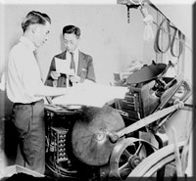
Titus N. Chao, Chinese American editor
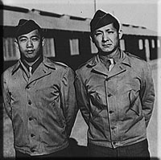
In the first decades of the new century, Chinese immigrants made slow steps toward greater inclusion in American life. Although the Exclusion Act was still in effect, the law did permit Chinese merchants, diplomats, and students to enter the country. For a time, these immigrants were even allowed to bring their wives and families. To take advantage of this loophole, young people often came into the U.S. by posing as family members of those with merchant status; these counterfeit family members became known as "paper sons" and "paper daughters".
In spite of all the legal and practical obstacles, between 1910 and 1940 some 175,000 Chinese immigrants passed through Angel Island Immigration Station, near San Francisco. At the same time, the growing number of children born to Chinese Americans helped add to the community's sense of permanence and stability. Since any child born in America automatically became a U.S. citizen, many parents bought property in their children's names, and were thus able to start businesses and make investments that would otherwise not have been available to them.
As more immigrants found professional work and achieved financial success, they began to move out of urban Chinatowns, often to new suburbs or other outlying neighborhoods. Despite continuing restrictions in immigration, the Chinese population of the U.S., which had dropped from about 107,000 in 1890 to a low of 61,000 in 1920, began to rise again.
The outbreak of the Second World War brought Chinese immigrants and their descendants even further into the mainstream of U.S. society. Japan's brutal invasion of China led to greater public sympathy for the Chinese people, and prompted Chinese Americans to register for the draft, to join in war industries, and to enlist in record numbers. San Francisco's Chinatown even built and funded its own pilot-training school to prepare Chinese American pilots to fight the Japanese air force. Of the 13,000 Chinese American soldiers who served during the war, almost half were not U.S. citizens, still barred by the Chinese Exclusion Act of 1882.
In 1943, the Exclusion Act was finally swept away, brought down by the pressures of wartime labor shortages and popular sentiment. Under new legislation, Chinese immigrants were finally made eligible for citizenship, and new quotas were set for immigration. Even greater changes came two years later, when the War Bride Act and the G.I. Fiancées Act permitted Chinese Americans to bring their wives into the country. Family life, for centuries one of the most cherished aspects of Chinese culture, was finally possible for the Chinese community in the United States.

A New Community
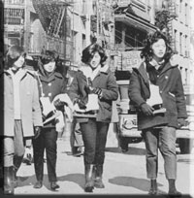
Chinese American women
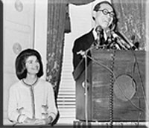
By the end of the 1960s, the Chinese American community had been transformed. After long decades of slow growth under tight constraints, Chinese immigration exploded, and brought a new, and very different, group of immigrants to America's shores.
A new immigration law passed in the mid-60s changed the way the U.S. counted its immigrant population. This law, the Immigration and Naturalization Act of 1965, allowed far more skilled workers and family members to enter the country than ever before, and eliminated the old quota system that gave preference to western Europeans. As a result, the Chinese American population in the U.S. almost doubled within ten years.
With the new surge of growth, the community changed. This new group of immigrants did not come from the same few rural provinces of China as the immigrants of the 1800s and early 1900s had. Instead, many came from urban Hong Kong and Taiwan. They had a different outlook on life than the earlier immigrants, who had created slow-paced, close-knit communities. The Hong Kong and Taiwan immigrants spoke different dialects, had more exposure to urban fashion and music, and had greater expectations of social mobility. Some were professionals, and they and their families integrated easily in cities throughout the United States. Others with less education and fewer skills tended to live in Chinatowns, and were subject to lower wages and worse living conditions than the previous generations. From the 1980s, many more people from China, including university students, joined the migration to the U.S., and many settled here permanently. As the flow of immigrants from Taiwan, China, and Hong Kong continues to remain steady, the Chinese American communities in both large cities and suburbs continue to adapt to the challenges that come with a growing and diverse culture.
In the meantime, Chinese immigrants and their descendants have had an increasingly great impact on U.S. culture. From the films of director Ang Lee and the novels of Amy Tan to the architecture of I.M. Pei and the hip-hop turntable skills of Kid Koala, Chinese Americans are becoming more prominent with every passing year, particularly in fashion and youth culture. As the community continues to grow, and as more movies, pop songs, and magazines that target young Asian American audiences begin to emerge, the role of Chinese Americans in American cultural life seems only likely to increase.
Looking back at the difficulties Chinese immigrants faced in their first hundred years in the U.S., would you have predicted their eventual success? What do you think accounts for this community's survival?

