German Immigration
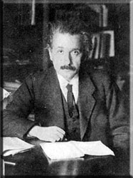
Albert Einstein
The German immigrant story is a long one—a story of early beginnings, continual growth, and steadily spreading influence. Germans were among the first Europeans to make their homes in the New World, and are among the United States' most recent arrivals. They were aboard the first boats that came ashore at Jamestown, and they built the rockets that took men to the moon. In the years in between, they moved into nearly every corner of the U.S., tried their hand at nearly every trade and pursuit, and helped shape the fundamental institutions of American life.
Though they endured their share of hardship, they escaped much of the tragedy and harsh treatment that plagued many immigrant groups. Today, more than 40 million Americans claim German ancestry—more than any other group except the British.
What factors might have contributed to the Germans' unique immigration experience?
The Call of Tolerance
William Penn in 1666
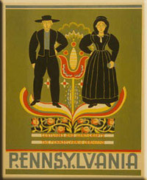
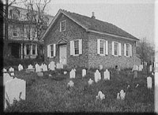
German immigrants were among the first Europeans to set foot in North America. They helped establish England’s Jamestown settlement in 1608 and the Dutch colony of New Amsterdam--now New York--in 1620. German adventurers could be found roaming the farthest reaches of the New World for many years afterward. It was religious tolerance, though, that first brought large numbers of Germans to North America.
During the 17th and 18th centuries, many European powers forced their subjects to follow an official state religion. Therefore, when William Penn toured Germany in 1677, spreading the word of a new kind of religious freedom in the American colonies, he found a receptive audience. Many Germans, especially Protestants, were persuaded to join him in his colony of Pennsylvania. Members of smaller sects, who were often persecuted in Europe, were especially eager to escape harassment, and German Mennonites, Quakers, and Amish emigrated in substantial numbers. Germantown, Pennsylvania--now part of Philadelphia--was established by 13 Mennonite families in 1683, and thousands of their fellow freethinkers and religious dissenters soon followed suit.
The journey to the colonies was not an easy one, though. Many of the first German immigrants came from the small Palatinate region in southwestern Germany. They began their travel by riverboat on the Rhine River, and then made their way to Holland. It took several weeks to reach an Atlantic seaport, and another eight to 10 weeks of difficult and dangerous ocean travel before they reached the shores of North America. To pay for their voyage, many impoverished immigrants resorted to selling themselves or their family members into indentured servitude--agreeing to be legally bound to an employer in America for several years, until their debt was paid. The conditions of indentured servitude could be very harsh; for instance, if an indentured child died before the contract was completed, the child's parents or siblings might be forced to work the remaining years of that contract, in addition to their own. Indentured servitude, unlike slavery, was entered into voluntarily, but it is still easy to see why German immigrants might have made a significant contribution to the anti-slavery movement in the United States.
Drawn by the prospect of inexpensive land, German immigrants quickly moved to settle on the fringes of the new colonies. Soon the river valleys of New York and Ohio were dotted with new German towns, and German settlements sprang up in Maryland, the Carolinas, and Georgia. Their stronghold, though, was still Pennsylvania. By 1745, more than 40,000 Germans lived in the colony, founding towns and villages with such distinctively German names as Manheim, Dunker, and Berlin. Many of these early communities maintain their German character to this day, especially in the Pennsylvania Dutch regions. (The term Pennsylvania Dutch was the result of Anglophone mispronunciation of the German word Deutsch, which means "German.") The Amish, who are members of an especially reclusive religious denomination, still speak German, reject modern conveniences, and retain the dress and way of life of the Pennsylvania German farmers of centuries ago.
Building a New Nation
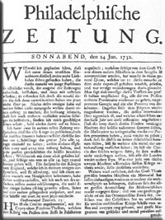
Front page of the
Philadelphische Zeitung
The Germans in America, 1732
Statue of Baron Von Steuben

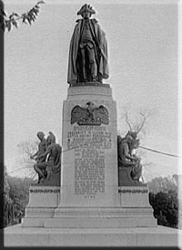
By the middle of the 18th century, German immigrants occupied a central place in American life. Germans accounted for one-third of the population of the American colonies, and were second in number only to the English. The German language was widely spoken in nearly every colonial city and was circulated in locally published periodicals and books. When the members of the Continental Congress first met in Philadelphia, they walked down streets lined with German businesses sporting German signs, and their deliberations were reported in German broadsides and debated in German coffeehouses. When the Declaration of Independence was signed on July 4, 1776, a German newspaper was the first to break the news, and German copies of the Declaration were on the streets the next day.
The strength and vitality of German publishing was one of the cornerstones of German culture in America, and one of the reasons for its tremendous success. Since Johannes Gutenberg invented movable type in 1440, Germans had been at the forefront of the printing industry in Europe, and they carried this tradition with them to the American colonies. The first Bible in America was published in German by Christopher Saur, a German printer in Philadelphia. By the time of the American Revolution, most of the cities and large towns in the colonies supported at least one German newspaper, and some had two. German newspapers, broadsides, almanacs, and books became the glue that held the German American community together, and helped maintain a sense of social cohesion among immigrants that were scattered widely up and down the eastern seaboard, in bustling cities and in remote farm settlements. This cultural glue held its force for hundreds of years, and reinforced German Americans' identity well into the 20th century.
The military traditions of German-speaking immigrants also made a significant contribution to revolutionary America. At the outbreak of the Revolutionary War, Germans from all over the American colonies formed volunteer militia companies. General Friedrich Wilhelm Von Steuben, who had served as a general staff officer with the Prussian army, volunteered to serve General George Washington without pay and was put to work organizing and drilling the sometimes ragged volunteers of the Continental Army. Von Steuben's Prussian discipline and tactics were to a large degree responsible for the Revolutionists' later military victories, and his manual of regulations formed the basis of the manual of drill and organization used by the United States Army today
A New Surge of Growth
German immigration boomed in the 19th century. Wars in Europe and America had slowed the arrival of immigrants for several decades starting in the 1770s, but by 1830 German immigration had increased more than tenfold. From that year until World War I, almost 90 percent of all German emigrants chose the United States as their destination. Once established in their new home, these settlers wrote to family and friends in Europe describing the opportunities available in the U.S. These letters were circulated in German newspapers and books, prompting "chain migrations." By 1832, more than 10,000 immigrants arrived in the U.S. from Germany. By 1854, that number had jumped to nearly 200,000 immigrants.
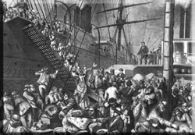
German immigrants boarding a ship for America
European Reading Room
For typical working people in Germany, who were forced to endure land seizures, unemployment, increased competition from British goods, and the repercussions of the failed German Revolution of 1848, prospects in the United States seemed bright. It soon became easier to leave Germany, as restrictions on emigration were eased. As steamships replaced sailing ships, the transatlantic journey became more accessible and more tolerable. As a result, more than 5 million people left Germany for the U.S. during the 19th century.
At the same time, the United States once again became a refuge for Germans fleeing persecution. Antisemitic violence in Germany and Austria-Hungary drove thousands of German Jews to emigrate. German Jews during this period were, by and large, proud of their German culture; they generally chose to speak German instead of Hebrew or Yiddish and lived together with Catholics and Lutherans in German American communities. While there were approximately 1500 European Jews living in the U.S. in 1800, there were almost 15,000 by the middle of the century.
Filling the Nation's Breadbasket
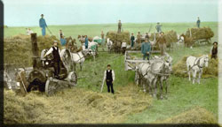
Threshing scene, Park River, North Dakota
For more than a century, hundreds of thousands of the newest German immigrants made their way to America's farm country, where they helped form the backbone of the nation's agriculture. As previous generations of Germans had before them, these immigrants made their homes on the outskirts of European settlement, where land was affordable. Germans poured into the available lands in the center of the North American continent--the valleys of the Mississippi, Ohio, and Missouri Rivers--and began farming the fertile land around the Great Lakes. By the mid-19th century, over half of the German-born people in North America lived in this region.
Later in the century, many Germans would head even farther west to the open spaces of Texas and the Dakotas--often traveling in the Conestoga wagons that Pennsylvania German farmers had invented to carry their crops to market. In the late 1800s, Germans joined the early settlers in the Pacific Northwest and California, where they were among the first to cultivate oranges, now one of the trademark crops of the American West.
Urban Germans
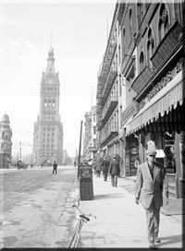
View of East Wells Street from
Market Street, Milwaukee, 1910.
Carl Schurz in 1877
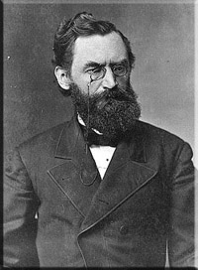
Even while German farmers were moving west, the urban German American population was growing as never before. Migration west led to concentrations of German immigrants in cities such as Cincinnati, Milwaukee, St. Louis, and St. Paul. Smaller communities founded by German immigrants often reflected the names of cities they had come from in Germany, such as Berlin, Wisconsin, and Frankfort, Kentucky.
An army of skilled German workers rolled into American cities during the 19th century, bringing with them the trades they had plied in their homeland. German Americans were employed in many urban craft trades, especially baking, carpentry, and the needle trades. Many German Americans worked in factories founded by the new generation of German American industrialists, such as John Bausch and Henry Lomb, who created the first American optical company; Steinway, Knabe and Schnabel (pianos); Rockefeller (petroleum); Studebaker and Chrysler (cars); H.J. Heinz (food); and Frederick Weyerhaeuser (lumber).
The social turmoil of Europe in the 19th century also sent many intellectuals and scholars to the United States. In particular, supporters of the German Revolution of 1848--sometimes called "Forty-Eighters"--brought their tradition of vigorous public debate and social activism to bear on the issues facing the U.S., including land reform, abolition, workers' rights, and women's suffrage. The student radical Carl Schurz, for example, escaped from Germany after the Revolution and settled in Wisconsin. In the course of a long public life, Schurz served his new country as a farmer, a lawyer, a journalist, a campaigner for Abraham Lincoln's Republican Party, a Union general, a cabinet official, a U.S. senator, an early member of the conservation movement, and the founder and editor of several newspapers, in both English and German.
However far they spread, though, and however diverse their ways of life might have been, Germans were still connected by the great web of German-language culture. German newspapers were available in most American cities, from California to Texas to Massachusetts, and German-language traveling speakers, theatrical performers, and popular songs all helped keep German Americans in touch with their cultural heritage.
Building Institutions, Shaping Tastes
As Germans became one of the predominant immigrant groups of the 19th century, it was only natural that they would come to have a powerful influence over the development of American culture. Some German contributions to U.S. life are easy to pinpoint--sauerkraut, for example, or the tuba, or the national fondness for light, fizzy beer. However, the German influence on life in the United States runs much deeper, influencing many of the institutions, traditions, and daily habits that many today think of as being quintessentially American.
For example, the U.S. education system, from the lowest grades to the highest, would be unrecognizable without ideas championed by German immigrants. German culture has long cultivated a strong commitment to education, and Germans brought this dedication with them to their new home. In 1855, German immigrants in Wisconsin launched the first kindergarten in America, based on the kindergartens of Germany. Germans introduced physical education and vocational education into the public schools, and were responsible for the inclusion of gymnasiums in school buildings. More important, they were leaders in the call for universal education, a notion not common in the U.S. at the time.
German immigrants also brought their reforming zeal to America's recreational life--it can even be argued that Germans invented the American weekend. Before the arrival of the Germans, many communities in the American colonies observed a Puritan sabbath, with an emphasis on rest and family time spent at home. Germans, however, had a long tradition of organized Sunday recreation and were enthusiastic devotees of the Sunday outing. After the arrival of German immigrants, new large-scale recreational facilities began to appear in U.S. towns--picnic grounds, bandstands, sports clubs, concert halls, bowling alleys, and playgrounds, all suitable for a weekend excursion with the family. Germans were also fond of social clubs, and formed singing societies, theater groups, and lodges. Anyone who uses one of today's theme parks, civic orchestras, swimming pools, or urban parks owes a debt to the German passion for recreation.
Traditions that many think of as being fundamentally American, as being part of the nation's heritage since time immemorial, were either introduced or popularized by German immigrants in the 19th century. Several of the most familiar elements of the American Christmas celebration, from the Christmas tree to the gift-giving Santa Claus, were gifts from the Germans, as was the Easter bunny.
By the end of the 19th century, German Americans and German culture were generally accepted as necessary threads in the fabric of American life. They were less geographically and culturally isolated than in previous generations and increasingly spoke English as a first, rather than a second, language, all the while maintaining a vital written culture in German. German was widely taught in American public schools and was studied by German and non-German students alike. German Americans were occasionally portrayed as figures of fun in the popular press, but they were seldom demonized. The coming years would see German Americans rise to even greater heights in American life; however, German American culture would not fare so well.
What other foods, celebrations, or traditions might be linked to German heritage?
Shadows of War
For German Americans, the 20th century was a time of growth and consolidation; their numbers increased, their finances became more stable, and Americans of German heritage rose to positions of great power and distinction. For German American culture, however, the new century was a time of severe setbacks--and a devastating blow from which it has never fully recovered.
The coming of World War I brought with it a backlash against German culture in the United States. When the U.S. declared war on Germany in 1917, anti-German sentiment rose across the nation, and German American institutions came under attack. Some discrimination was hateful, but cosmetic: The names of schools, foods, streets, and towns, were often changed, and music written by Wagner and Mendelssohn was removed from concert programs and even weddings. Physical attacks, though rare, were more violent: German American businesses and homes were vandalized, and German Americans accused of being "pro-German" were tarred and feathered, and, in at least once instance, lynched.
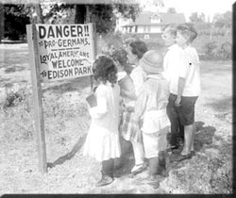
Anti-German sign, Chicago, 1917
Second Division, Germany, 1919
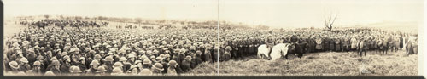
The most pervasive damage was done, however, to German language and education. German-language newspapers were either run out of business or chose to quietly close their doors. German-language books were burned, and Americans who spoke German were threatened with violence or boycotts. German-language classes, until then a common part of the public-school curriculum, were discontinued and, in many areas, outlawed entirely. None of these institutions ever fully recovered, and the centuries-old tradition of German language and literature in the United States was pushed to the margins of national life, and in many places effectively ended.
President Woodrow Wilson spoke disapprovingly of "hyphenated Americans" whose loyalty he claimed was divided. One government official warned that "Every citizen must declare himself American--or traitor." Many German Americans struggled with their feelings, realizing that sympathy for their homeland appeared to conflict with loyalty to the U.S.
Some German Americans reacted by overtly defending their loyalty to the United States. Others changed the names of their businesses, and sometimes even their own names, in an attempt to conceal German ties and to disappear into mainstream America. Ironically, and contrary to Wilson's opinion about divided loyalties, thousands of German Americans fought to defend America in World War I, led by German American John J. Pershing, whose family had long before changed their name from Pfoerschin.
Fifteen years later, the shadows of a new war brought another surge in immigration. When Germany's Nazi party came to power in 1933, it triggered a significant exodus of artists, scholars and scientists, as Germans and other Europeans fled the coming storm. Most eminent among this group was a pacifist Jewish scientist named Albert Einstein.
Anti-German feelings arose again during World War II, but they were not as powerful as they had been during the first World War. The loyalty of German Americans was not questioned as virulently. Dwight Eisenhower, a descendant of the Pennsylvania Dutch and future president of the United States, commanded U.S. troops in Europe. Two other German Americans, Admiral Chester Nimitz of the United States Navy and General Carl Spaatz of the Army Air Corps, were by Eisenhower's side and played key roles in the struggle against Nazi Germany.
World War II, industrial expansion, and Americanization efforts reinforced the cultural assimilation of many German Americans. After the war, one more surge of German immigrants arrived in the United States, as survivors of the conflict sought to escape its grim aftermath. These new arrivals were extremely diverse in their political viewpoints, their financial status, and their religious beliefs, and settled throughout the U.S.
German immigration to the United States continues to this day, though at a slower pace than in the past, carrying on a tradition of cultural enrichment over 400 years old—a tradition that has helped shape much of what we today consider to be quintessentially American.

