Introduction
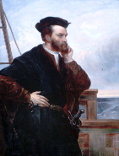
When Jacques Cartier first came to the unexplored continent later called North America looking for a short cut to Asia's silks and spices in 1534, he hoped to find gold and precious metals. He didn't find gold, but he did find riches -- furs. The fur trade became the start of French exploration and settlement in the "new" continent. First came the fur traders themselves, who made money by trading for furs with the Native people. Then came settlers, hoping to claim the land for the king of France. As the French began to stay in this new, unexplored territory, more people came over from France -- farmers, carpenters, priests, nuns, workers and soldiers. The population grew and flourished. Today there are French-speaking people in every part of Canada, especially in Quebec.
Port-Royal
After Europeans found out about this "new" continent, the king of France decided that he should send people to settle there in order to claim the land for France. He called this land New France. Building settlements and looking after the settlers was expensive so he offered to give all the rights to fur trading to one person and in exchange they would have to bring settlers to New France.
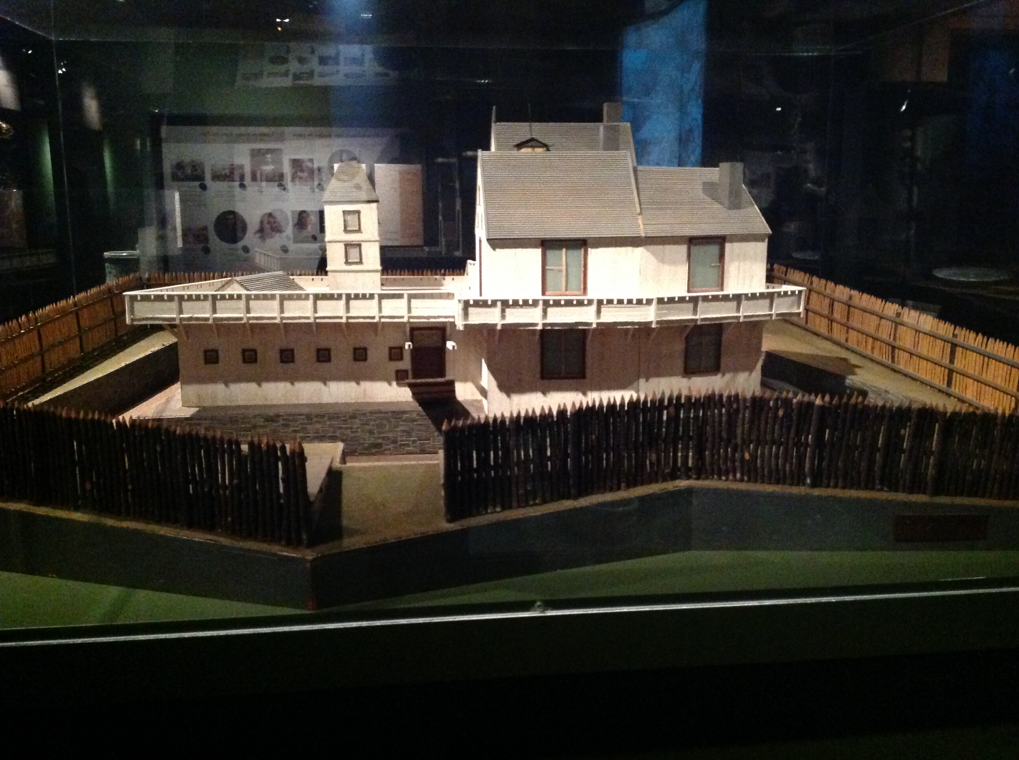
Quebec City

In 1603, King Henry IV of France gave Pierre Du Gua de Monts a monopoly on the fur trade in New France. That year De Monts, his mapmaker Samuel de Champlain and the crew left France on the ship Bonne Renommée and arrived at Tadoussac, a fur-trading centre, to start a colony. In the first year of the settlement, only five of 16 men survived. In 1604, de Monts and Champlain began a new colony on Île Sainte-Croix in the Baie Française (now called the Bay of Fundy). But the conditions were harsh and 35 of 79 men died. In 1605, they moved the settlement to sheltered harbour across the bay in what is now Nova Scotia. They called this new settlement Port-Royal, and it became the capital of Acadia, the first colony in New France.
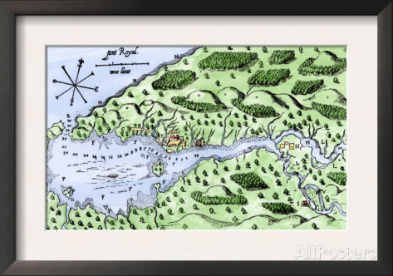
Map of Port-Royal by Champlain, 1613
The French built a wooden fort, two stories high, with a courtyard in the middle. They planted wheat and vegetables outside the fort to help feed them throughout the winter. In order to take the men's minds off the long cold winter, Champlain began a tradition called the Order of Good Cheer. Each man took his turn to plan an evening of entertainment and a delicious feast. The person who was planning the evening had to catch or hunt the main course and cook the food. Roasts of moose, duck, goose, rabbit, bear, porcupine, beaver tail or fish might be served. He was also responsible for organizing the entertainment, which might be music or skits. These evenings helped to keep the men's health and spirits up.
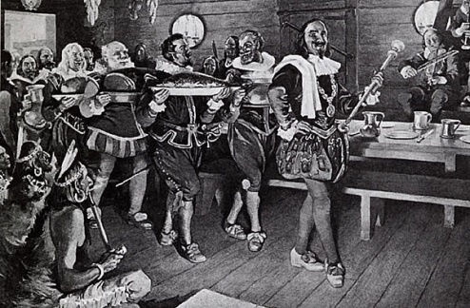
Evening feast in the tradition of Champlain's Order of Good Cheer
The French formed good relations with the Mi'kmaq and traded with them for furs. The colonists had made it through the winter well, but one day news came from France that the king had ended de Monts' monopoly on fur trading. The settlement could not continue without a supply of men, profits from furs and supplies. Port-Royal was abandoned in 1607 and the settlers returned to France.
Way of Life
Despite the fact that the Native peoples had been living, hunting, fishing and raising crops on the "new" continent for thousands of years, in the sixteenth century the French king claimed the land in New France belonged to France.
The land along the rivers was divided into long thin strips called rotures and given to important people called seigneurs. These were men who were friendly with the king. The land ran from the river to the forest. Each family got a strip to farm. The tenant farmer was called a habitant. He had to build a house, clear and farm his land, pay taxes to the seigneur and work on the seigneur's land a few days each year. In return, the seigneur was expected to build a mill, pay part of the cost of building a church and to help build bridges and roads. When a habitant's sons grew up, the land was divided into thinner strips and one was given to each son.

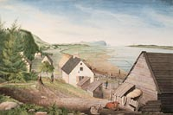
A typical seigneury (farm) near Québec, watercolour by Thomas Davies, circa 1787
Life was hard for the habitants. They had to first clear their land, cutting down trees with an axe and removing tree stumps and rocks. They then had to grow crops. They grew wheat for bread and hay for their animals. They raised chickens and pigs, kept cows for milk and meat, sheep for wool, and horses to pull plows and sleighs.
Children had many farm chores to do such as weeding and hoeing the garden. Even though life was hard, it was better than what they could expect in France. In New France, they owned their own farms and there was plenty of wood for heating and lots of fish and wild animals for eating. When they weren't working, families liked to visit friends and family and have parties. Such events had lots of good food, singing, and dancing.
Diseases such as cholera and smallpox provided hardships for many families and wiped out Aboriginal populations.
Culture
Language: Today the French in Canada differs slightly from the French spoken in France. It also differs from the French spoken by present-day Acadians.
Religion: Every Sunday, families would go to their parish church, which was Roman Catholic. At church they would enjoy meeting up with their friends and neighbours. Not only were they there to worship, but also to trade news with each other and to hear the announcements from the governor or bishop that were read in church.

