Irish Immigrants

Colonial Immigration
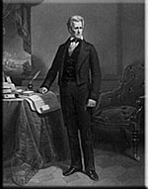
Andrew Jackson
In colonial times, the Irish population in America was second in number only to the English. Many early Irish immigrants were of sturdy, Scotch-Irish stock. Pushed out of Ireland by religious conflicts, lack of political autonomy and dire economic conditions, these immigrants were pulled to America by the promise of land ownership and greater religious freedom.
Most Scotch-Irish immigrants were educated, skilled workers. Even those who financed their emigration by becoming indentured servants were well equipped to lead successful, independent lives when their period of servitude ended. They were readily assimilated into the life of the new nation.
The Scotch-Irish settled in the middle colonies, especially in Pennsylvania where the city of Philadelphia was a major port of debarkation. Over subsequent decades, the Scotch-Irish migrated south following the Great Philadelphia Road, the main route used for settling the interior southern colonies. Traveling down Virginia’s Shenandoah Valley, then south into the North Carolina Piedmont region, they reached South Carolina by the 1760s. Settlers here often became frontiersmen and Indian fighters.
Presidents Andrew Jackson and Ronald Reagan traced their roots to these early Americans.
Irish-Catholic Immigration to America
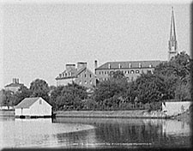
The Carroll Mansion and St. Mary's from
the Spa [Creek], Annapolis, Md.
Irish-Catholic immigrants came to America during colonial times, too, and not all Irish-Catholic immigrants were poor. For example, wealthy Charles Carroll immigrated to America in 1706. His grandson, Charles Carroll of Carrollton, signed his name to the Declaration of Independence.
Ireland’s 1845 Potato Blight is often credited with launching the second wave of Irish immigration to America. The fungus which decimated potato crops created a devastating famine. Starvation plagued Ireland and within five years, a million Irish were dead while half a million had arrived in America to start a new life. Living conditions in Ireland were deplorable long before the Potato Blight of 1845, however, and a large number of Irish left their homeland as early as the 1820s.
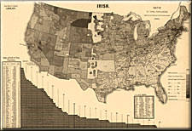
1880: Irish in America
In fact, Ireland’s population decreased dramatically throughout the nineteenth century. Census figures show an Irish population of 8.2 million in 1841, 6.6 million a decade later, and only 4.7 million in 1891. It is estimated that as many as 4.5 million Irish arrived in America between 1820 and 1930.
Between 1820 and 1860, the Irish constituted over one third of all immigrants to the United States. In the 1840s, they comprised nearly half of all immigrants to this nation. Interestingly, pre-famine immigrants from Ireland were predominately male, while in the famine years and their aftermath, entire families left the country. In later years, the majority of Irish immigrants were women. What can these statistics tell us about life in Ireland during this period?
Adaptation and Assimilation
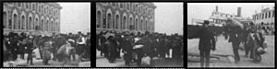
Arrival of emigrants, Ellis Island
The Irish immigrants left a rural lifestyle in a nation lacking modern industry. Many immigrants found themselves unprepared for the industrialized, urban centers in the United States. Though these immigrants were not the poorest people in Ireland (the poorest were unable to raise the required sum for steerage passage on a ship to America), by American standards, they were destitute.
They often had no money beyond the fare for their passage, and, thus, settled in the ports of their debarkation. In time, the sum total of Irish-Americans exceeded the entire population of Ireland. New York City boasted more Irishmen than Dublin, Ireland!
The Irish established patterns that newcomers to the United States continue to follow today. Housing choices, occupations entered, financial support to families remaining in the homeland, and chain immigrations which brought additional relatives to America, are some of these patterns.
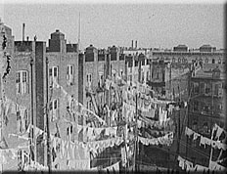
New York, NY, yard of tenement
(between 1900 and 1910)
Irish immigrants often crowded into subdivided homes that were intended for single families, living in tiny, cramped spaces. Cellars, attics and make-do spaces in alleys became home. Not only were many immigrants unable to afford better housing, but the mud huts in which many had lived in Ireland had lowered their expectations.
A lack of adequate sewage and running water in these places made cleanliness next to impossible. Disease of all kinds (including cholera, typhus, tuberculosis, and mental illness) resulted from these miserable living conditions. Thus, when the Irish families moved into neighborhoods, other families often moved out fearing the real or imagined dangers of disease, fire hazards, unsanitary conditions and the social problems of violence, alcoholism and crime.
How might the living conditions of the Irish have influenced their acceptance in the United States? How do living patterns of new immigrant groups affect their acceptance in the United States today? Who determines these patterns or conditions?
Joining the Workforce
Irish immigrants often entered the workforce at the bottom of the occupational ladder and took on the menial and dangerous jobs that were often avoided by other workers. Many Irish women became servants or domestic workers, while many Irish men labored in coal mines and built railroads and canals. Railroad construction was so dangerous that it was said, "[there was] an Irishman buried under every tie."
As Irish immigrants moved inland from eastern cities, they found themselves in heated competition for jobs. The audio recording, Immigrant Laborers in the Early 20th Century, describes how West Virginia coal operators fired union laborers and gave the jobs to Irish, Italian and African-American workers because, “[the] coal company owned them.” This competition heightened class tensions and, at the turn of the century, Irish Americans were often antagonized by organizations such as the American Protective Association (APA) and the Ku Klux Klan.
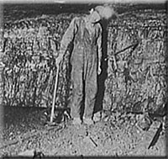
Coal Mine
The Irish often suffered blatant or subtle job discrimination. Furthermore, some businesses took advantage of Irish immigrants’ willingness to work at unskilled jobs for low pay. Employers were known to replace (or threaten to replace) uncooperative workers and those demanding higher wages with Irish laborers.
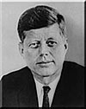
President
John F. Kennedy
Over time, many Irish climbed occupational and social ladders through politically appointed positions such as policeman, fireman, and teacher. Second and third generation Irish were better educated, wealthier, and more successful than were their parents and grandparents, as illustrated by the Kennedy family. The first Kennedy who arrived in the United States in 1848 was a laborer. His son had modest success in this country, but his grandson, college educated Joseph P. Kennedy, made the fortune that enabled the great grandsons (one of whom became President John F. Kennedy) to achieve great political success.
Religious Conflict and Discrimination
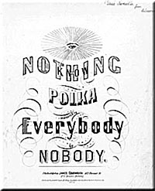
"A sheet music cover..."
Prints and Photographs Online Catalog
Ill will toward Irish immigrants because of their poor living conditions, and their willingness to work for low wages was often exacerbated by religious conflict. Centuries of tension between Protestants and Catholics found their way into United States cities and verbal attacks often led to mob violence. For example, Protestants burned down St. Mary’s Catholic Church in New York City in 1831, while in 1844, riots in Philadelphia left thirteen dead.
Anti-immigrant and anti-Catholic sentiments in the 1840s produced groups such as the nativist American Party, which fought foreign influences and promoted "traditional American ideals." American Party members earned the nickname, "Know-Nothings," because their standard reply to questions about their procedures and activities was, "I know nothing about it."
In the Questions for Admittance to the American Party (1854), inductees committed to "…elect to all offices of Honor, Profit, or Trust, no one but native born citizens of America, of this Country to the exclusion of all Foreigners, and to all Roman Catholics, whether they be of native or Foreign Birth, regardless of all party predilections whatever." This commitment helped elect American Party governors in Massachusetts and Delaware and placed Millard Fillmore on a presidential ticket in 1856.
Racial Tensions
"A sheet music cover..."
Prints and Photographs Online Catalog
During much of the nineteenth century, when large numbers of Irish and Blacks were present, they were pushed into competition. There are striking parallels in the culture and history of the two groups. They began their life in America with low social and economic status. Over time, they advanced in common fields such as sports, entertainment, religion, writing and publishing, and politics. They even had similar social pathologies—alcoholism, violence and broken homes. Rather than being united by their common hard life, they were divided by the need to compete. For political benefit, this pattern was reinforced as Blacks were drawn to the Republican Party while the Irish strength in numbers was wooed by the Democratic Party.
Both the Irish and Blacks had reason to feel they were treated unfairly in the workforce, and often at one another's expense. In the antebellum South, for instance, where slaveholders viewed slaves as valuable property, Blacks were prohibited from participating in hazardous, life-threatening work. Thus, many of the most dangerous jobs were left to the Irish who did not have such protection (or limitation). Thousands of Irish lives were lost in the building of the nation's canal and railroad systems.
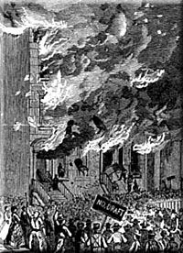
The Riot in Lexington Avenue
The Conscription Act of 1863 exacerbated tense relationships. This act made all white men between the ages of twenty and forty-five years eligible for the draft by the Union Army. Free black men were permitted to "volunteer" to fight in the Civil War through the provisions of the Emancipation Proclamation. However, Blacks were not drafted or otherwise forced to fight. In addition, white men with money could illegally bribe doctors for medical exemptions, legally hire a substitute, or pay for a commutation of a draft. Lower-class workers could not afford to pay for deferments. The inequities in draft eligibility between blacks, monied whites, and lower-class whites (many of whom were Irish), inevitably increased racial tensions.
Several cities suffered draft riots in which enrollment officers and free blacks were targeted for violence. The largest such incident began on June 11, 1863, in New York City when more than 100 people were murdered by an angry mob. After burning down a draft office and attacking police officers and well-dressed whites, this mob of lower-class whites (including many Irish) focused its energy on killing black bystanders. The Report of the Committee of Merchants for the Relief of Colored People . . . documents some of the acts perpetrated by the mob in the section, Incidents of the Riot.
Irish Identity, Influence and Opportunity
Even as violence threatened the stability of many cities, there was cause to celebrate American self-reliance and Irish-American spirit. John Francis Maguire’s The Irish in America (1868) proclaimed the immigrant to be "… the architect of his country’s greatness, the author of her civilization, the miracle-worker by whom all has been or can be accomplished."
For centuries, though legally free, the Irish lived as a conquered people in their own nation. Britain controlled the politics, economics and religious life of Ireland. Subjugation and strife gave rise to an unmistakable Irish identity, a sense of cohesion, and an ability to organize to accomplish goals. The Irish often met their economic, educational, religious and social needs through clandestine means that frequently involved their trusted village priests.
Their organizational ability coupled with the large number of Irish living in U.S. cities, made the Irish a powerful political force. They literally transformed politics in American cities by putting local power in the hands of men of working class origin. Building on principles of loyalty to the individual and the organization, they built powerful political machines capable of getting the vote. Though remembered most for their perceived corruption, these political machines created social services long before they were politically mandated by national political movements.
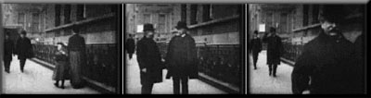
Dick Croker leaving Tammany Hall, 1900
Political machines controlled major American cities into the 20th century. From New York to San Francisco, the Irish dominated big city politics. New York's Tammany political machine was under Irish control for more than fifty years.
Irish influence resulted in increased power for the Democratic Party as well as the Catholic Church. William R. Grace became New York City’s first Irish-Catholic mayor in 1880. Four years later, Hugh O’Brien won the same position in Boston.
Irish-American political clout led to increased opportunities for the Irish-American. Looking out for their own, the political machines made it possible for the Irish to get jobs, to deal with naturalization issues, even to get food or heating fuel in emergencies. The political machines also rewarded their own through political appointments. In 1855, "...nearly 40% of New York City's policemen were immigrants, and about three-fourths of these immigrants were Irish."[Wittke, The Irish in America]
Irish Contributions to the American Culture
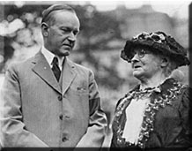
Mother Jones
Despite the competition for jobs, many Irish immigrants supported and became leaders of union efforts, perhaps because they so well understood the power of organizing to meet needs. For instance, Mary Harris, later known as Mother Jones, committed more than fifty years of her life to unionizing workers in various occupations throughout the country. Her dedicated effort resulted in arrests, personal attacks, and many hardships but she also earned audiences with United States presidents from McKinley to Coolidge.
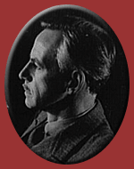
Portrait of Eugene O'Neill
New Deal appointments a decade later enabled Irish politicians to gain the national spotlight through judgeships and other federal positions. These appointments served as precursors to the future success of Irish-American elected leaders such as Chicago Mayor Richard Daley and President John F. Kennedy.
The great number of Irish who entered the United States from the sixteenth to twentieth centuries were changed by America, just as they changed this nation. They achieved lives that would not have been possible in Ireland, supporting their families and bringing a better life to their fellow Irish in the United States and in Ireland.
In turn these immigrants contributed to the "American culture" in many ways. They became political and religious leaders. They used their drive and charm (and their "way with words") to achieve special success in journalism, entertainment and sports. Popular perceptions of the fierce Irish temper, introduced such terms as "Paddy Wagon," "Donnybrook" and "Fighting Irish" to the American language. Among the early immigrants to the United States, the Irish are now assimilated in all aspects of this nation, but they still retain pride and identity in their Irish heritage.

